Week 4_5. JWT-handson
HandsOn_1. Securing RESTful Web Services with Spring Security
SecurityConfig.java
package com.example.jwt_auth_demo.config;

import com.example.jwt_auth_demo.filter.JwtRequestFilter;
import com.example.jwt_auth_demo.service.CustomUserDetailsService;
import org.springframework.beans.factory.annotation.Autowired;
import org.springframework.context.annotation.*;
import org.springframework.security.authentication.*;
import org.springframework.security.config.annotation.authentication.configuration.*;
import org.springframework.security.config.annotation.web.builders.HttpSecurity;
import org.springframework.security.config.http.SessionCreationPolicy;
import org.springframework.security.web.SecurityFilterChain;
import org.springframework.security.web.authentication.UsernamePasswordAuthenticationFilter;
import org.springframework.security.crypto.bcrypt.BCryptPasswordEncoder;
import org.springframework.security.crypto.password.PasswordEncoder;

@Configuration
public class SecurityConfig {

@Autowired
private JwtRequestFilter jwtRequestFilter;

@Autowired
private CustomUserDetailsService userDetailsService;

@Bean
public AuthenticationManager authenticationManager(AuthenticationConfiguration config) throws Exception {
return config.getAuthenticationManager();
}

@Bean
public PasswordEncoder passwordEncoder() {
return new BCryptPasswordEncoder(); // optional, not used in this demo
}

@Bean
public SecurityFilterChain filterChain(HttpSecurity http) throws Exception {
http.csrf().disable()
.authorizeHttpRequests(auth -> auth
.requestMatchers("/authenticate").permitAll()
.anyRequest().authenticated()
)
.sessionManagement(session -> session.sessionCreationPolicy(SessionCreationPolicy.STATELESS));

http.addFilterBefore(jwtRequestFilter, UsernamePasswordAuthenticationFilter.class);
return http.build();
}

}
AuthController.java
package com.example.jwt_auth_demo.controller;

import com.example.jwt_auth_demo.model.AuthRequest;
import com.example.jwt_auth_demo.model.AuthResponse;
import com.example.jwt_auth_demo.util.JwtUtil;
import org.springframework.beans.factory.annotation.Autowired;
import org.springframework.security.authentication.*;
import org.springframework.security.core.userdetails.UserDetails;
import org.springframework.web.bind.annotation.*;

@RestController
public class AuthController {

@Autowired
private AuthenticationManager authManager;

@Autowired
private JwtUtil jwtUtil;

@Autowired
private com.example.jwt_auth_demo.service.CustomUserDetailsService userDetailsService;

@PostMapping("/authenticate")
public AuthResponse createToken(@RequestBody AuthRequest request) throws Exception {
try {
authManager.authenticate(
new UsernamePasswordAuthenticationToken(request.getUsername(), request.getPassword()));
} catch (BadCredentialsException e) {
throw new Exception("Incorrect username or password", e);
}

final UserDetails userDetails = userDetailsService.loadUserByUsername(request.getUsername());
final String jwt = jwtUtil.generateToken(userDetails);

return new AuthResponse(jwt);
}

@GetMapping("/hello")
public String hello() {
return "Hello, this is a secured endpoint!";
}
}
JwtRequestFilter.java
package com.example.jwt_auth_demo.filter;

import com.example.jwt_auth_demo.service.CustomUserDetailsService;
import com.example.jwt_auth_demo.util.JwtUtil;
import org.springframework.beans.factory.annotation.Autowired;
import org.springframework.security.authentication.*;
import org.springframework.security.core.context.SecurityContextHolder;
import org.springframework.security.core.userdetails.UserDetails;
import org.springframework.stereotype.Component;
import org.springframework.web.filter.OncePerRequestFilter;
import jakarta.servlet.FilterChain;
import jakarta.servlet.ServletException;
import jakarta.servlet.http.HttpServletRequest;
import jakarta.servlet.http.HttpServletResponse;

import java.io.IOException;

@Component
public class JwtRequestFilter extends OncePerRequestFilter {

@Autowired
private CustomUserDetailsService userDetailsService;

@Autowired
private JwtUtil jwtUtil;

@Override
protected void doFilterInternal(HttpServletRequest request,
HttpServletResponse response,
FilterChain chain) throws ServletException, IOException {

final String authHeader = request.getHeader("Authorization");

String username = null;
String jwt = null;

if (authHeader != null && authHeader.startsWith("Bearer ")) {
jwt = authHeader.substring(7);
username = jwtUtil.extractUsername(jwt);
}

if (username != null && SecurityContextHolder.getContext().getAuthentication() == null) {
UserDetails userDetails = userDetailsService.loadUserByUsername(username);

if (jwtUtil.validateToken(jwt, userDetails)) {
UsernamePasswordAuthenticationToken token =
new UsernamePasswordAuthenticationToken(userDetails, null, userDetails.getAuthorities());

token.setDetails(new WebAuthenticationDetailsSource().buildDetails(request));
SecurityContextHolder.getContext().setAuthentication(token);
}
}

chain.doFilter(request, response);
}
}
AuthRequest.java
package com.example.jwt_auth_demo.model;

public class AuthRequest {
private String username;
private String password;

// Getters and Setters
public String getUsername() { return username; }
public void setUsername(String username) { this.username = username; }
public String getPassword() { return password; }
public void setPassword(String password) { this.password = password; }
}
AuthResponse.java
package com.example.jwt_auth_demo.model;

public class AuthResponse {
private final String jwt;

public AuthResponse(String jwt) {
this.jwt = jwt;
}

public String getJwt() {
return jwt;
}
}
CustomUserDetailsService.java
package com.example.jwt_auth_demo.service;

import org.springframework.security.core.userdetails.*;
import org.springframework.stereotype.Service;
import java.util.*;

@Service
public class CustomUserDetailsService implements UserDetailsService {
@Override
public UserDetails loadUserByUsername(String username) throws UsernameNotFoundException {
// Demo only: hardcoded user
if ("user".equals(username)) {
return new User("user", "{noop}password", new ArrayList<>());
}
throw new UsernameNotFoundException("User not found");
}
}

JwtUtil.java
package com.example.jwt_auth_demo.util;

import io.jsonwebtoken.*;
import org.springframework.security.core.userdetails.UserDetails;
import org.springframework.stereotype.Service;

import java.util.Date;
import java.util.HashMap;
import java.util.Map;
import java.util.function.Function;

@Service
public class JwtUtil {

private String SECRET_KEY = "secret123";

public String extractUsername(String token) {
return extractClaim(token, Claims::getSubject);
}

public Date extractExpiration(String token) {
return extractClaim(token, Claims::getExpiration);
}

private <T> T extractClaim(String token, Function<Claims, T> resolver) {
final Claims claims = extractAllClaims(token);
return resolver.apply(claims);
}

private Claims extractAllClaims(String token) {
return Jwts.parser().setSigningKey(SECRET_KEY).parseClaimsJws(token).getBody();
}

private boolean isTokenExpired(String token) {
return extractExpiration(token).before(new Date());
}

public String generateToken(UserDetails userDetails) {
Map<String, Object> claims = new HashMap<>();
return createToken(claims, userDetails.getUsername());
}

private String createToken(Map<String, Object> claims, String subject) {
return Jwts.builder().setClaims(claims).setSubject(subject)
.setIssuedAt(new Date(System.currentTimeMillis()))
.setExpiration(new Date(System.currentTimeMillis() + 1000 * 60 * 60)) // 1 hour
.signWith(SignatureAlgorithm.HS256, SECRET_KEY).compact();
}

public boolean validateToken(String token, UserDetails userDetails) {
return extractUsername(token).equals(userDetails.getUsername()) && !isTokenExpired(token);
}
}
JwtAuthDemoApplication.java
package com.example.jwt_auth_demo;

import org.springframework.boot.SpringApplication;
import org.springframework.boot.autoconfigure.SpringBootApplication;

@SpringBootApplication
public class JwtAuthDemoApplication {
public static void main(String[] args) {
SpringApplication.run(JwtAuthDemoApplication.class, args);
}
}
application.properties
spring.application.name=code
server.port=8088
CodeApplicationTests.java
package com.example.jwt_auth_demo;

import org.junit.jupiter.api.Test;
import org.springframework.boot.test.context.SpringBootTest;

@SpringBootTest
class CodeApplicationTests {

@Test
void contextLoads() {
}

}

OUTPUT
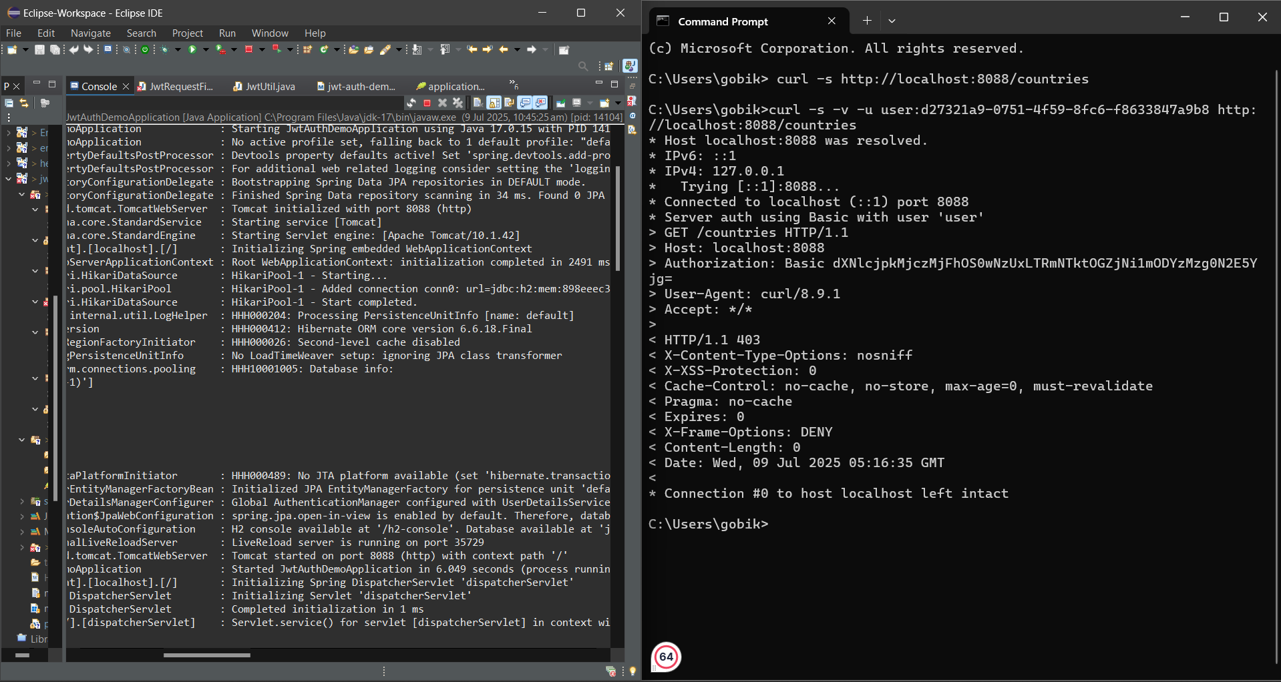
HandsOn_2. Creating users and roles in Spring Security
SecurityConfig.java
package com.example.securitydemo.config;

import org.slf4j.Logger;
import org.slf4j.LoggerFactory;
import org.springframework.context.annotation.Bean;
import org.springframework.context.annotation.Configuration;
import org.springframework.security.authentication.AuthenticationManager;
import org.springframework.security.config.annotation.authentication.configuration.AuthenticationConfiguration;
import org.springframework.security.config.annotation.web.configuration.EnableWebSecurity;
import org.springframework.security.config.annotation.web.builders.HttpSecurity;
import org.springframework.security.core.userdetails.User;
import org.springframework.security.core.userdetails.UserDetailsService;
import org.springframework.security.crypto.bcrypt.BCryptPasswordEncoder;
import org.springframework.security.crypto.password.PasswordEncoder;
import org.springframework.security.provisioning.InMemoryUserDetailsManager;
import org.springframework.security.web.SecurityFilterChain;

@Configuration
@EnableWebSecurity
public class SecurityConfig {

private static final Logger LOGGER = LoggerFactory.getLogger(SecurityConfig.class);

@Bean
public PasswordEncoder passwordEncoder() {
LOGGER.info("Initializing BCryptPasswordEncoder");
return new BCryptPasswordEncoder();
}

// Define in-memory users
@Bean
public UserDetailsService userDetailsService() {
InMemoryUserDetailsManager manager = new InMemoryUserDetailsManager();
manager.createUser(User.withUsername("admin")
.password(passwordEncoder().encode("pwd"))
.roles("ADMIN")
.build());
manager.createUser(User.withUsername("user")
.password(passwordEncoder().encode("pwd"))
.roles("USER")
.build());
return manager;
}

// Configure which roles can access which endpoints
@Bean
public SecurityFilterChain securityFilterChain(HttpSecurity http) throws Exception {
http.csrf().disable()
.httpBasic()
.and()
.authorizeHttpRequests()
.requestMatchers("/countries").hasRole("USER")
.anyRequest().authenticated();
return http.build();
}

// Required for authentication manager
@Bean
public AuthenticationManager authenticationManager(AuthenticationConfiguration config) throws Exception {
return config.getAuthenticationManager();
}
}
CountryController.java
package com.example.securitydemo.controller;

import org.springframework.web.bind.annotation.GetMapping;
import org.springframework.web.bind.annotation.RestController;

import java.util.Arrays;
import java.util.List;

@RestController
public class CountryController {

@GetMapping("/countries")
public List<String> getCountries() {
return Arrays.asList("India", "USA", "Germany", "Japan");
}
}
SecurityDemoApplication.java
package com.example.securitydemo;

import org.springframework.boot.SpringApplication;
import org.springframework.boot.autoconfigure.SpringBootApplication;

@SpringBootApplication
public class SecurityDemoApplication {
public static void main(String[] args) {
SpringApplication.run(SecurityDemoApplication.class, args);
}
}
application.properties
spring.application.name=code
server.port=8088
logback-spring.xml
<?xml version="1.0" encoding="UTF-8"?>
<configuration>
<include resource="org/springframework/boot/logging/logback/defaults.xml"/>

<property name="LOG_FILE" value="application.log"/>
<property name="LOG_PATH" value="logs"/>

<appender name="FILE" class="ch.qos.logback.core.FileAppender">
<file>${LOG_PATH}/${LOG_FILE}</file>
<encoder>
<pattern>%d{yyyy-MM-dd HH:mm:ss} [%thread] %-5level %logger{36} - %msg%n</pattern>
</encoder>
</appender>

<appender name="CONSOLE" class="ch.qos.logback.core.ConsoleAppender">
<encoder>
<pattern>%d{yyyy-MM-dd HH:mm:ss} %5p [%t] %c{1} - %m%n</pattern>
</encoder>
</appender>

<root level="INFO">
<appender-ref ref="CONSOLE"/>
<appender-ref ref="FILE"/>
</root>
</configuration>
CodeApplicationTests.java
package com.example.securitydemo;

import org.junit.jupiter.api.Test;
import org.springframework.boot.test.context.SpringBootTest;

@SpringBootTest
class CodeApplicationTests {

@Test
void contextLoads() {
}

}
OUTPUT
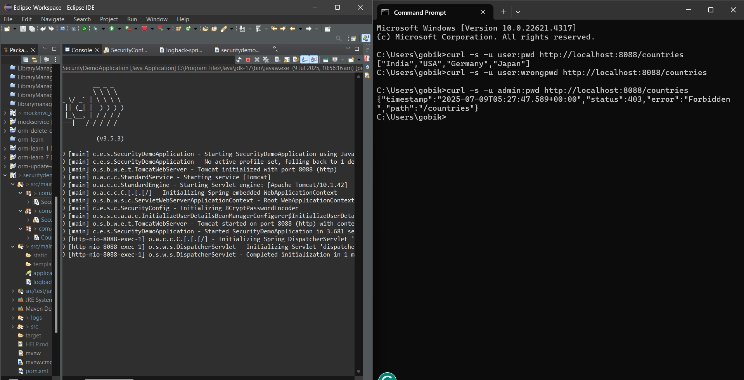
HandsOn_3. Understanding JWT
What is JWT?
- JWT stands for JSON Web Token.
- It is a compact, URL-safe token format used to represent claims securely between two parties.
- Commonly used for authentication and authorization in web applications.

JWT Process Flow
- Client sends username and password to the server.
- Server validates the credentials and generates a JWT.
- JWT is returned to the client.
- Client includes the JWT in the Authorization header for future requests (Bearer <token>).
- Server validates the JWT in each request to ensure authenticity.

JWT Structure
A JWT is composed of three parts separated by dots (.):
Header.Payload.Signature
1. Header
Specifies the algorithm and token type.
Example:
{
"alg": "HS256",
"typ": "JWT"
}
2. Payload
Contains application-specific data (claims), such as user information.
Example:
{
"sub": "user",
"role": "USER",
"iat": 1516239022
}
3. Signature
Generated using the header, payload, and a secret key. It ensures the integrity and authenticity of the token.

Hands-On Activity Steps
- Open the Wikipedia page on JWT: JWT Structure
- Open https://jwt.io in another tab.
- Copy the Header and Payload examples from Wikipedia and paste them into the respective fields on jwt.io.
- In the Verify Signature field, type "secretkey" (without quotes).
- Check if the generated token in the Encoded section matches the one on Wikipedia.
Note: You may see a warning saying:
"A key of 256 bits or larger MUST be used with HS256 as specified in RFC 7518."
This means your secret key should be at least 32 characters long for better security.

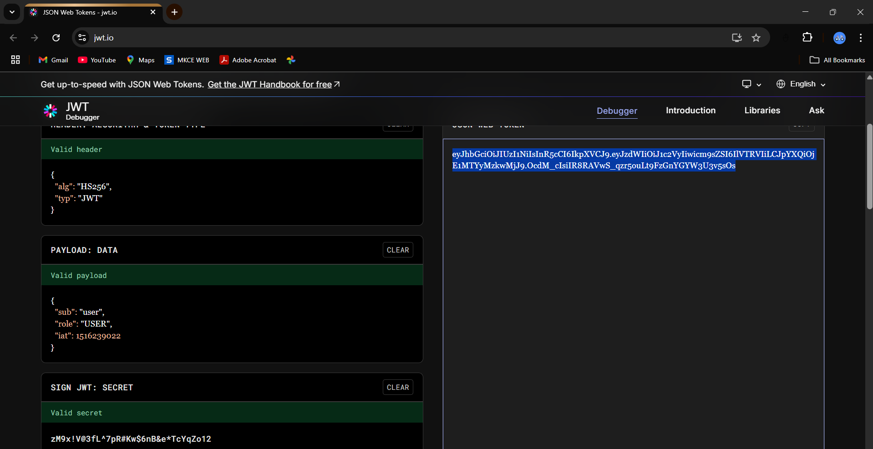
HandsOn_4. Create authentication service that returns JWT

SecurityConfig.java
package com.example.jwtauth.config;

import org.springframework.context.annotation.Bean;
import org.springframework.context.annotation.Configuration;
import org.springframework.security.config.annotation.web.builders.HttpSecurity;
import org.springframework.security.web.SecurityFilterChain;

@Configuration
public class SecurityConfig {

@Bean
public SecurityFilterChain filterChain(HttpSecurity http) throws Exception {
http
.csrf(csrf -> csrf.disable())
.authorizeHttpRequests(auth -> auth.anyRequest().permitAll());
return http.build();
}
}
AuthController.java
package com.example.jwtauth.controller;

import com.example.jwtauth.util.JwtUtil;
import org.springframework.http.ResponseEntity;
import org.springframework.web.bind.annotation.*;

import java.util.Base64;
import jakarta.servlet.http.HttpServletRequest;

@RestController
public class AuthController {

@GetMapping("/authenticate")
public ResponseEntity<?> authenticate(HttpServletRequest request) {
String header = request.getHeader("Authorization");

if (header == null || !header.startsWith("Basic ")) {
return ResponseEntity.status(401).body("Missing or invalid Authorization header.");
}

String base64Credentials = header.substring("Basic ".length());
byte[] decodedBytes = Base64.getDecoder().decode(base64Credentials);
String credentials = new String(decodedBytes);
String[] parts = credentials.split(":", 2);

String username = parts[0];
String password = parts[1];

// For demo: hardcoded validation
if ("user".equals(username) && "pwd".equals(password)) {
String token = JwtUtil.generateToken(username);
return ResponseEntity.ok().body("{\"token\":\"" + token + "\"}");
} else {
return ResponseEntity.status(401).body("Invalid username or password.");
}
}
}
JwtService.java
package com.example.jwtauth.service;

import io.jsonwebtoken.Jwts;
import io.jsonwebtoken.SignatureAlgorithm;
import io.jsonwebtoken.security.Keys;
import org.springframework.stereotype.Service;

import java.security.Key;
import java.util.Date;

@Service
public class JwtService {

// Use a secure 256-bit key (can be loaded from application.properties)
private static final Key key = Keys.hmacShaKeyFor("mysecretkeymysecretkeymysecretkey12".getBytes()); // 32+ chars

public String generateToken(String username) {
return Jwts.builder()
.setSubject(username)
.setIssuedAt(new Date(System.currentTimeMillis()))
.setExpiration(new Date(System.currentTimeMillis() + 1000 * 60 * 60)) // 1 hour validity
.signWith(key, SignatureAlgorithm.HS256)
.compact();
}
}
JwtUtil.java
package com.example.jwtauth.util;

import io.jsonwebtoken.Jwts;
import io.jsonwebtoken.SignatureAlgorithm;
import io.jsonwebtoken.security.Keys;

import java.security.Key;
import java.util.Date;

public class JwtUtil {

private static final Key SECRET_KEY = Keys.hmacShaKeyFor("ThisIsASecretKeyForJwtTokenGeneration12345".getBytes());

public static String generateToken(String username) {
long currentTimeMillis = System.currentTimeMillis();
return Jwts.builder()
.setSubject(username)
.setIssuedAt(new Date(currentTimeMillis))
.setExpiration(new Date(currentTimeMillis + 10 * 60 * 1000)) // 10 minutes
.signWith(SECRET_KEY, SignatureAlgorithm.HS256)
.compact();
}
}
JwtAuthApplication.java
package com.example.jwtauth;

import org.springframework.boot.SpringApplication;
import org.springframework.boot.autoconfigure.SpringBootApplication;

@SpringBootApplication
public class JwtAuthApplication {
public static void main(String[] args) {
SpringApplication.run(JwtAuthApplication.class, args);
}
}
application.properties
spring.application.name=code
server.port=8088

CodeApplicationTests.java
package com.example.jwtauth;
import org.junit.jupiter.api.Test;
import org.springframework.boot.test.context.SpringBootTest;
@SpringBootTest
class CodeApplicationTests {
@Test
void contextLoads() {
}
}
OUTPUT
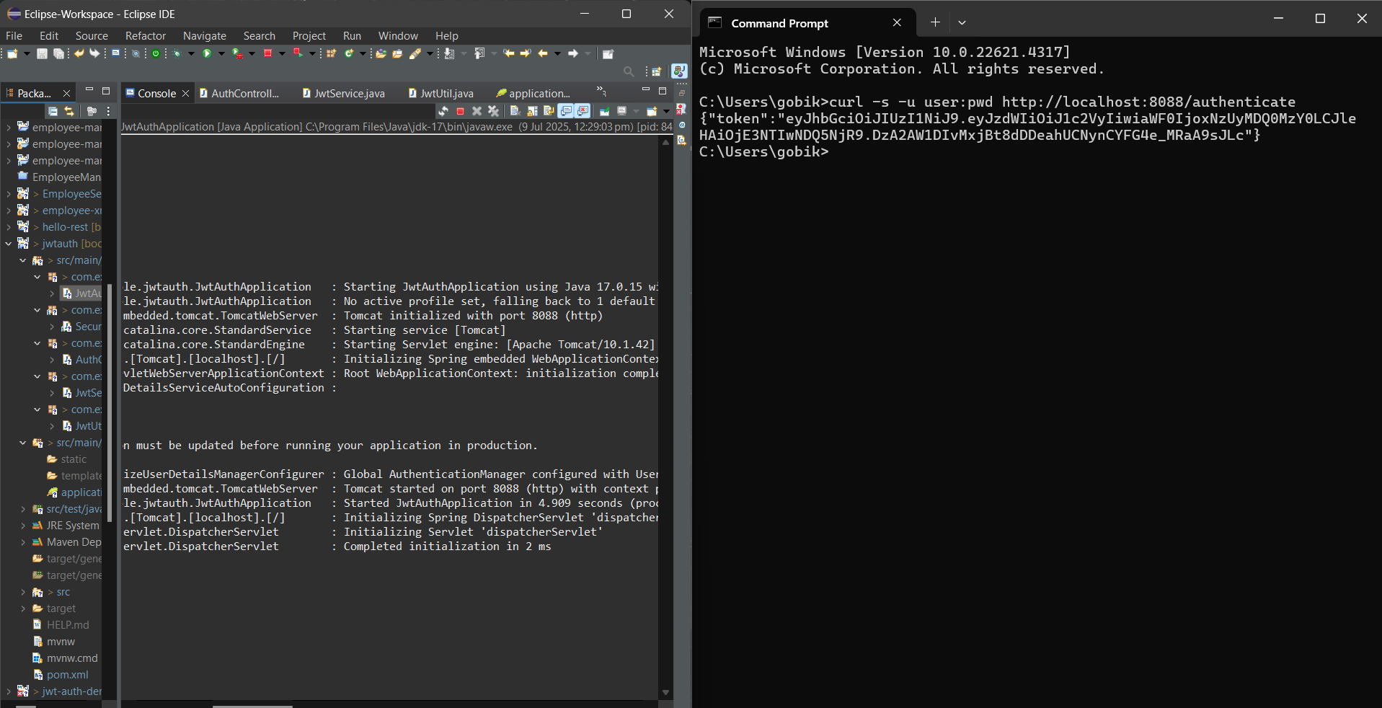

HandsOn_5. Create authentication controller and configure it in SecurityConfig
SecurityConfig.java
package com.example.jwtauth_2.config;

import org.springframework.context.annotation.Bean;
import org.springframework.context.annotation.Configuration;
import org.springframework.security.config.annotation.web.builders.HttpSecurity;
import org.springframework.security.web.SecurityFilterChain;
import org.springframework.security.core.userdetails.User;
import org.springframework.security.core.userdetails.UserDetails;
import org.springframework.security.provisioning.InMemoryUserDetailsManager;
import org.springframework.security.core.userdetails.UserDetailsService;
import org.springframework.security.crypto.bcrypt.BCryptPasswordEncoder;
import org.springframework.security.crypto.password.PasswordEncoder;

@Configuration
public class SecurityConfig {

@Bean
public SecurityFilterChain securityFilterChain(HttpSecurity http) throws Exception {
return http
.authorizeHttpRequests(auth -> auth
.requestMatchers("/authenticate").hasAnyRole("USER", "ADMIN")
.anyRequest().authenticated()
)
.httpBasic()
.and()
.csrf().disable()
.build();
}

@Bean
public UserDetailsService userDetailsService() {
UserDetails user = User
.withUsername("user")
.password(passwordEncoder().encode("pwd"))
.roles("USER")
.build();
return new InMemoryUserDetailsManager(user);
}

@Bean
public PasswordEncoder passwordEncoder() {
return new BCryptPasswordEncoder();
}
}
AuthenticationController.java
package com.example.jwtauth_2.controller;

import org.slf4j.Logger;
import org.slf4j.LoggerFactory;
import org.springframework.web.bind.annotation.*;

import java.util.HashMap;
import java.util.Map;

@RestController
public class AuthenticationController {

Logger logger = LoggerFactory.getLogger(AuthenticationController.class);

@GetMapping("/authenticate")
public Map<String, String> authenticate(@RequestHeader("Authorization") String authHeader) {
logger.info("Start - /authenticate");
logger.debug("Authorization Header: {}", authHeader);

Map<String, String> map = new HashMap<>();
map.put("token", ""); // We'll generate real JWT later
logger.info("End - /authenticate");
return map;
}
}
JwtAuth2Application.java
package com.example.jwtauth_2;
import org.slf4j.Logger;
import org.slf4j.LoggerFactory;
import org.springframework.boot.SpringApplication;
import org.springframework.boot.autoconfigure.SpringBootApplication;
@SpringBootApplication
public class JwtAuth2Application {
private static final Logger logger = LoggerFactory.getLogger(JwtAuth2Application.class);
public static void main(String[] args) {
SpringApplication.run(JwtAuth2Application.class, args);
logger.info("Application Started");
}
}
application.properties
spring.application.name=code
server.port=8088
logging.level.com.example.jwtauth_2=DEBUG
logging.level.root=INFO
CodeApplicationTests.java
package com.example.jwtauth_2;
import org.junit.jupiter.api.Test;
import org.springframework.boot.test.context.SpringBootTest;
@SpringBootTest
class CodeApplicationTests {
@Test
void contextLoads() {
}
}
OUTPUT
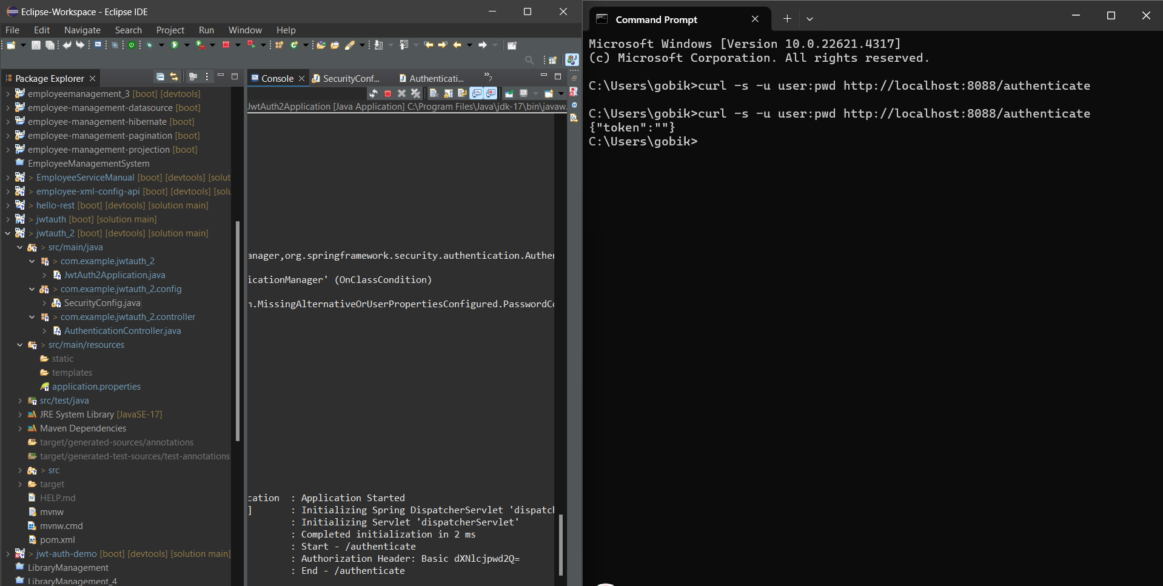

HandsOn_6. Read Authorization header and decode the username and password
AuthenticationController.java
package com.example.decodename.controller;

import org.slf4j.Logger;
import org.slf4j.LoggerFactory;
import org.springframework.web.bind.annotation.*;

import java.util.Base64;

@RestController
@RequestMapping("/api")
public class AuthenticationController {

private static final Logger LOGGER = LoggerFactory.getLogger(AuthenticationController.class);

@PostMapping("/authenticate")
public String authenticate(@RequestHeader("Authorization") String authHeader) {
String user = getUser(authHeader);
LOGGER.info("Authenticated user: {}", user);
return "Authenticated user: " + user;
}
@GetMapping("/ping")
public String ping() {
return "API is live!";
}

private String getUser(String authHeader) {
if (authHeader != null && authHeader.startsWith("Basic ")) {
String encodedCredentials = authHeader.substring("Basic ".length());
byte[] decodedBytes = Base64.getDecoder().decode(encodedCredentials);
String decodedString = new String(decodedBytes); // example: "gobika:pass"
LOGGER.debug("Decoded credentials: {}", decodedString);
String username = decodedString.split(":")[0];
return username;
}
return "Unknown";
}
}
SecurityConfig.java
package com.example.decodename.security;

import org.springframework.context.annotation.Bean;
import org.springframework.context.annotation.Configuration;
import org.springframework.security.config.annotation.web.builders.HttpSecurity;
import org.springframework.security.web.SecurityFilterChain;

@Configuration
public class SecurityConfig {

@Bean
public SecurityFilterChain filterChain(HttpSecurity http) throws Exception {
http
.csrf(csrf -> csrf.disable())
.authorizeHttpRequests(auth -> auth
.requestMatchers("/api/authenticate").permitAll()
.anyRequest().authenticated()
)
.httpBasic(httpBasic -> httpBasic.disable()); // Disable default Basic Auth

return http.build();
}
}
DecodenameApplication.java
package com.example.decodename;

import org.springframework.boot.SpringApplication;
import org.springframework.boot.autoconfigure.SpringBootApplication;

@SpringBootApplication
public class DecodenameApplication {
public static void main(String[] args) {
SpringApplication.run(DecodenameApplication.class, args);
}
}
application.properties
spring.application.name=code
server.port=8088
logging.level.com.example=DEBUG
logging.level.com.example.decodename=DEBUG
CodeApplicationTests.java
package com.example.decodename;

import org.junit.jupiter.api.Test;
import org.springframework.boot.test.context.SpringBootTest;

@SpringBootTest
class CodeApplicationTests {

@Test
void contextLoads() {
}

}
OUTPUT
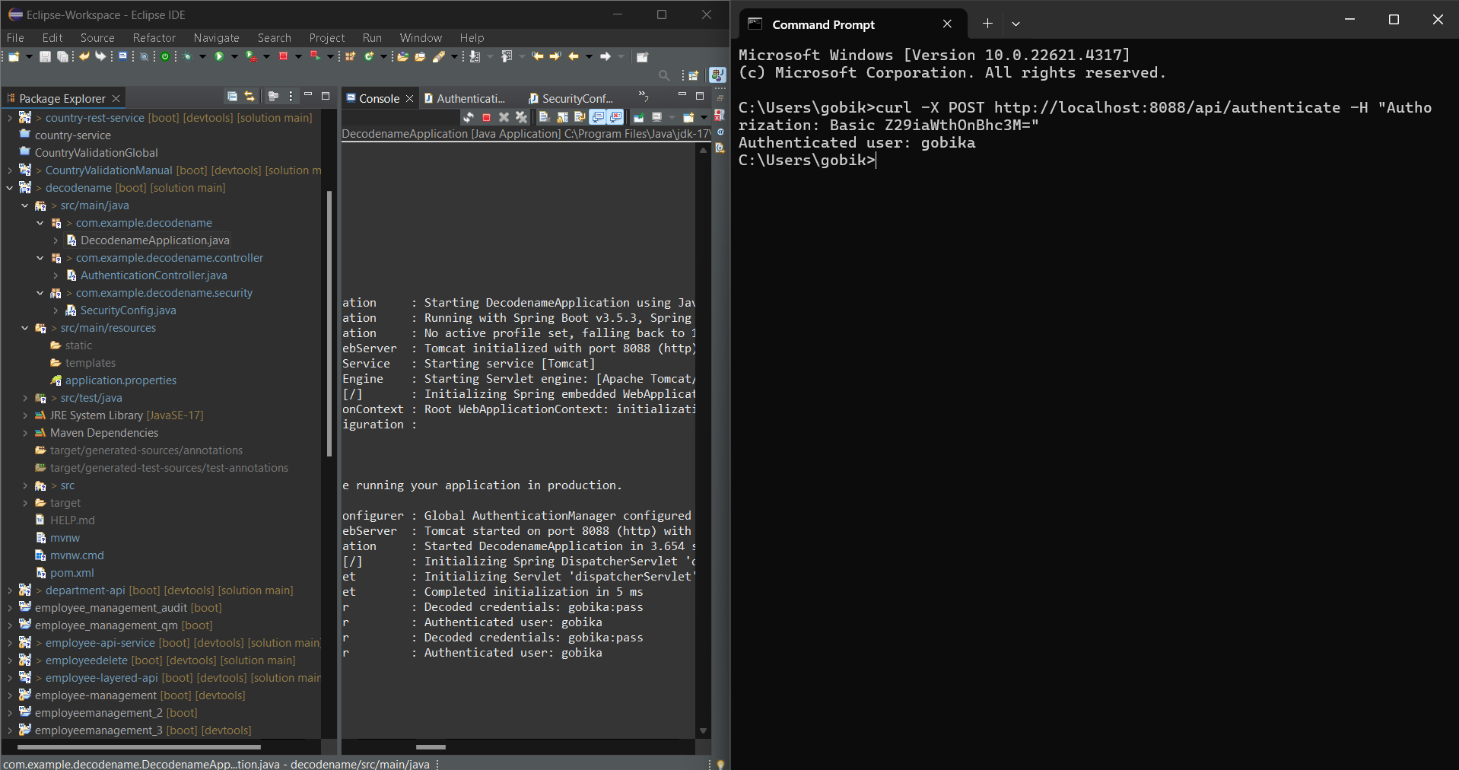

HandsOn_7. Generate token based on the user
AuthenticationController.java
package com.gobika.jwt.controller;

import io.jsonwebtoken.Jwts;
import io.jsonwebtoken.security.Keys;
import org.springframework.web.bind.annotation.*;

import java.security.Key;
import java.util.Date;
import java.util.HashMap;
import java.util.Map;

@RestController
@RequestMapping("/api")
public class AuthenticationController {

@PostMapping("/authenticate")
public Map<String, String> authenticate(@RequestParam String username) {
Map<String, String> response = new HashMap<>();

if (username != null && !username.trim().isEmpty()) {
String token = generateJwt(username);
response.put("token", token);
} else {
response.put("error", "Invalid user");
}

return response;
}

private String generateJwt(String username) {
// Key must be at least 256 bits for HS256
Key key = Keys.hmacShaKeyFor("mysecretkeymysecretkeymysecretkey12".getBytes()); // 32 characters

return Jwts.builder()
.setSubject(username)
.setIssuedAt(new Date())
.setExpiration(new Date(System.currentTimeMillis() + 20 * 60 * 1000)) // 20 minutes
.signWith(key)
.compact();
}
}
JwtDemoApplication.java
package com.gobika.jwt;

import org.springframework.boot.SpringApplication;
import org.springframework.boot.autoconfigure.SpringBootApplication;

@SpringBootApplication
public class JwtDemoApplication {
public static void main(String[] args) {
SpringApplication.run(JwtDemoApplication.class, args);
}
}
application.properties
spring.application.name=code
server.port=8088
CodeApplicationTests.java
package com.gobika.jwt;

import org.junit.jupiter.api.Test;
import org.springframework.boot.test.context.SpringBootTest;

@SpringBootTest
class CodeApplicationTests {

@Test
void contextLoads() {
}

}
OUTPUT
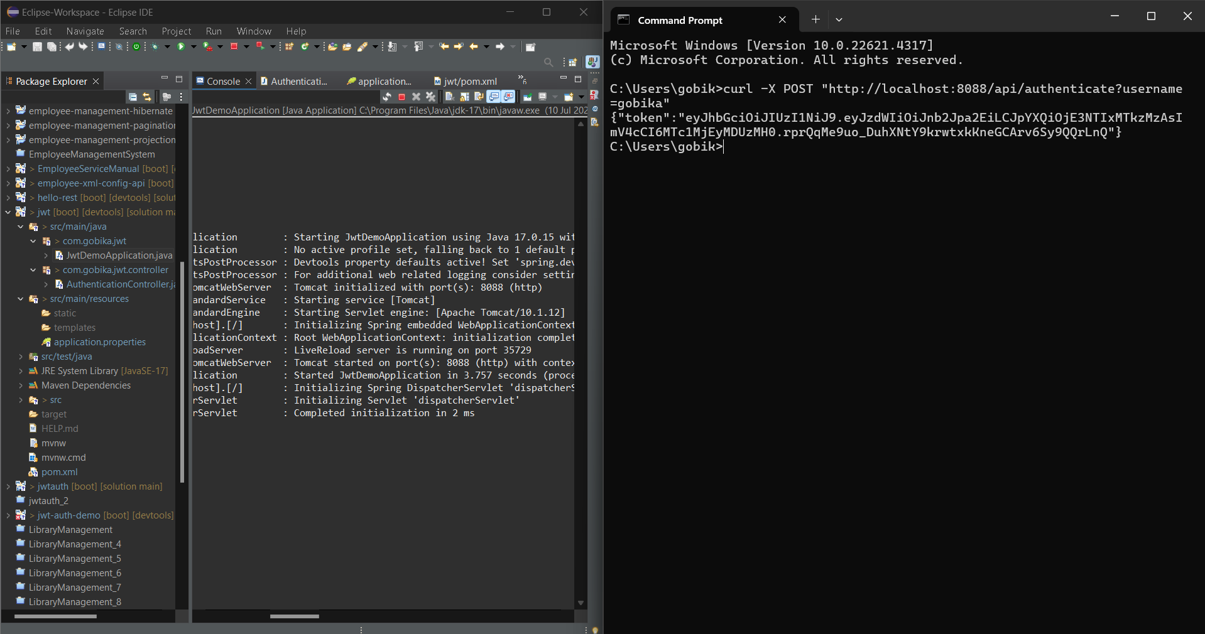
HandsOn_8. Authorize based on JWT
AuthenticationController.java
package com.example.auth.controller;

import com.example.auth.util.JwtUtil;
import org.springframework.web.bind.annotation.*;

@RestController
@RequestMapping("/api")
public class AuthenticationController {

@GetMapping("/ping")
public String ping() {
return "Application is alive!";
}

@PostMapping("/authenticate")
public String authenticate(@RequestParam String username, @RequestParam String password) {
if ("gobika".equals(username) && "pass".equals(password)) {
return JwtUtil.generateToken(username);
} else {
return "Invalid credentials";
}
}

@GetMapping("/hello")
public String hello() {
return "Hello, secured world!";
}
}
JwtAuthorizationFilter.java
package com.example.auth.security;

import com.example.auth.util.JwtUtil;
import jakarta.servlet.FilterChain;
import jakarta.servlet.ServletException;
import jakarta.servlet.http.HttpServletRequest;
import jakarta.servlet.http.HttpServletResponse;
import org.springframework.security.authentication.AuthenticationManager;
import org.springframework.security.authentication.UsernamePasswordAuthenticationToken;
import org.springframework.security.core.context.SecurityContextHolder;
import org.springframework.security.web.authentication.www.BasicAuthenticationFilter;

import java.io.IOException;
import java.util.ArrayList;

public class JwtAuthorizationFilter extends BasicAuthenticationFilter {

public JwtAuthorizationFilter(AuthenticationManager authenticationManager) {
super(authenticationManager);
}

@Override
protected void doFilterInternal(HttpServletRequest request, HttpServletResponse response, FilterChain chain)
throws IOException, ServletException {

String header = request.getHeader("Authorization");

if (header == null || !header.startsWith("Bearer ")) {
chain.doFilter(request, response);
return;
}

String token = header.replace("Bearer ", "");

if (JwtUtil.validateToken(token)) {
String username = JwtUtil.extractUsername(token);
UsernamePasswordAuthenticationToken auth = new UsernamePasswordAuthenticationToken(username, null, new ArrayList<>());
SecurityContextHolder.getContext().setAuthentication(auth);
}

chain.doFilter(request, response);
}
}
SecurityConfig.java
package com.example.auth.security;

import org.springframework.context.annotation.Bean;
import org.springframework.context.annotation.Configuration;
import org.springframework.security.authentication.AuthenticationManager;
import org.springframework.security.config.annotation.authentication.configuration.AuthenticationConfiguration;
import org.springframework.security.config.annotation.web.builders.HttpSecurity;
import org.springframework.security.web.SecurityFilterChain;

@Configuration
public class SecurityConfig {

@Bean
public SecurityFilterChain filterChain(HttpSecurity http, AuthenticationManager authenticationManager) throws Exception {
http.csrf().disable()
.authorizeHttpRequests()
.requestMatchers("/api/authenticate", "/api/ping").permitAll()
.anyRequest().authenticated()
.and()
.addFilter(new JwtAuthorizationFilter(authenticationManager));

return http.build();
}

@Bean
public AuthenticationManager authenticationManager(AuthenticationConfiguration authConfig) throws Exception {
return authConfig.getAuthenticationManager();
}
}
JwtUtil.java
package com.example.auth.util;

import io.jsonwebtoken.*;
import io.jsonwebtoken.security.Keys;

import java.security.Key;
import java.util.Date;

public class JwtUtil {

private static final String SECRET_KEY = "this_is_a_secure_256_bit_secret_key_123!";
private static final long EXPIRATION_TIME = 60 * 60 * 1000; // 1 hour

private static final Key key = Keys.hmacShaKeyFor(SECRET_KEY.getBytes());

public static String generateToken(String username) {
return Jwts.builder()
.setSubject(username)
.setIssuedAt(new Date())
.setExpiration(new Date(System.currentTimeMillis() + EXPIRATION_TIME))
.signWith(key, SignatureAlgorithm.HS256)
.compact();
}

public static boolean validateToken(String token) {
try {
Jwts.parserBuilder().setSigningKey(key).build().parseClaimsJws(token);
return true;
} catch (JwtException | IllegalArgumentException e) {
return false;
}
}

public static String extractUsername(String token) {
return Jwts.parserBuilder()
.setSigningKey(key)
.build()
.parseClaimsJws(token)
.getBody()
.getSubject();
}
}
AuthApplication.java
package com.example.auth;

import org.springframework.boot.SpringApplication;
import org.springframework.boot.autoconfigure.SpringBootApplication;

@SpringBootApplication
public class AuthApplication {
public static void main(String[] args) {
SpringApplication.run(AuthApplication.class, args);
}
}
application.properties
spring.application.name=code
server.port=8088
management.endpoints.web.exposure.include=health
CodeApplicationTests.java
package com.example.auth;

import org.junit.jupiter.api.Test;
import org.springframework.boot.test.context.SpringBootTest;

@SpringBootTest
class CodeApplicationTests {

@Test
void contextLoads() {
}

}

OUTPUT
